Implementation of Swarm Intelligence algorithms in classical problems

PROJECT SYNOPSIS
SUBMITTED IN PARTIAL FULFILLMENT OF THE REQUIREMENTS
FOR THE
DEGREE OF BACHELOR OF TECHNOLOGY
IN
Department of Computer Science & Engineering

BY
NAME | Registration No: | Roll No:
SOUMYA DEEP SAMANTA | 161420110049 | 14200116021
SOURAV DAS | 161420110051 | 14200116019
SAYAK HALDAR | 161420110045 | 14200116025
PRITAM KUMAR RAY | 161420110033 | 14200116037

Under The Supervision
of
Dr. Sutirtha Kumar Guha, Assistant Professor


DEPARTMENT OF Computer Science & Engineering
MEGHNAD SAHA INSTITUTE OF TECHNOLOGY
Techno Complex, Madurdaha, Beside NRI Complex, post-Uchhepota, Kolkata-700150
Affiliated by

DECEMBER 2019

CANDIDATE’S DECLARATION

I hereby declare that the Synopsis Report which is being prepared based on the project entitled “Implementation of Swarm Intelligence algorithms in classical problems” for the partial fulfillment of the requirement for the degree of B.Tech. in Computer Science and Engineering, submitted to the Department of Computer Science & Engineering of MEGHNAD SAHA INSTITUTE OF TECHNOLOLY under MAULANA ABUL KALAM AZAD UNIVERSITY OF TECHNOLOGY, KOLKATA is an authentic record of our own work carried out during Odd Semester 2019 under the supervision of Dr. Sutirtha Kumar Guha. The matter presented in this project has not been submitted by us in any other University / Institute for any award.

_________________________
Signature of the Students
With Date


Nazirabad, P.O. :Utchepota, Via Sonarpur, Kolkata 700 150

CERTIFICATE OF APPROVAL
The foregoing project entitled “Implementation of Swarm Intelligence algorithms in classical problems” is hereby approved as a creditable study of an engineering subject carried out and presented in a manner satisfactory to warrant its acceptance as prerequisite for the degree for which it has been submitted. It is to be understood that by this approval the undersigned do not necessarily endorse or approve any statement made, opinion expressed or conclusion drawn therein but approve the thesis only for the purpose for which it has been submitted.
__________________________
Board of Examiners __________________________
__________________________
__________________________
__________________________
Project Guide __________________________

Head of the Department __________________________

Date:
Place: [Departmental & College Seal]
Abstract

Swarm intelligence is a research branch that models the population of interacting agents or swarms that are able to self organise. An ant colony , a flock of birds or bees swarming around their hive are some of the examples of swarm intelligence (SI). The complex social behaviours of ants ,birds, or the bees have been much studied by science, and computer scientists are now finding that ,these behaviour patterns can provide models for solving difficult combinatorial optimisation problems. It is known that classical optimisation procedures are not adequate for this problem. In this work , three typical combinatorial problems (graph colouring ,travelling salesman problem and N-queen problem ) have been taken and each of them are solved using various SI algorithms. Based on the outcome of the above application we tried to draw a comparative analysis between each SI algorithms.

Keywords: Ant colony optimization, artificial bee colony optimization, particle swarm optimization, graph coloring, traveling salesman problem, continuous optimization, n- queen problem.

TABLE OF CONTENTS

Contents | Page No.
Introduction ………………………………………………… | Page-6
Related Work…………… ………………………………….. | Page-8
Proposed Work………………….……………..…….………. | Page-12
Conclusion …………………………………………………... | Page-13
References …………………………………………………... | Page-14

Introduction:
1.1 Background:
Nature has so many varieties of incidents and methods that it often gives us solution in most unexpected way. Implementation of Swarm Intelligence is such kind of example. Swarm Intelligence is the collective behaviour of decentralized, self-organised systems, natural or artificial. Swarm Intelligence methods are all inspired from nature events. For example, ant colony, bee colony, bird flocking, fish schooling etc. So, in swarm intelligence we are concerned with only those animals who shows some collective behaviours and understands others in the group. The typical swarm intelligence system has the following properties:
- it is composed of many individuals;
- the individuals are relatively homogeneous (i.e., they are either all identical or they belong to a few typologies);
- the interactions among the individuals are based on simple behavioural rules that exploit only local information that the individuals exchange directly or via the environment (stigmergy);
- the overall behaviour of the system results from the interactions of individuals with each other and with their environment, that is, the group behaviour self-organizes.
The characterizing property of a swarm intelligence system is its ability to act in a coordinated way without the presence of a coordinator or of an external controller. Many examples can be observed in nature of swarms that perform some collective behaviour without any individual controlling the group, or being aware of the overall group behaviour. Notwithstanding the lack of individuals in charge of the group, the swarm as a whole can show an intelligent behaviour. This is the result of the interaction of spatially neighbouring individuals that act on the basis of simple rules.

1.2 Problem Domain:
The domain of the project is broadly on Swarm Intelligence. The main idea of our project is to solve some classical problems of computer science (already solved by classical approach) by Swarm Intelligence methods. We will implement various techniques of swarm intelligence to solve a particular problem.

1.3 Why Swarm Intelligence:
Many optimization problems in science and engineering are challenging to solve, and the current trend is to use swarm intelligence (SI) and SI-based algorithms to tackle such challenging problems. Some significant developments have been made in recent years, though there are still many open problems in this area. This paper provides a short but timely analysis about SI-based algorithms and their links with self-organization. Different characteristics and properties are analyzed here from both mathematical and qualitative perspectives. Future research directions are outlined and open questions are also highlighted. It is expected that using swarm intelligence we can solve many unsolved problems in computer science and can increase the efficiency of already solved problems by reducing the time and space complexity.

2. RELATED WORK

Swarm Intelligence is the emergent collective intelligence of groups of simple agents. Population of simple agents interacting locally with one another and with their environment. The inspiration often comes from nature, especially biological systems. An ant colony , a flock of birds or bees swarming around their hive are some of the examples of swarm intelligence (SI).
The Traveling Salesman Problem (often called TSP) is a classic algorithmic problem in the field of computer science and operational research [1].We can use the brute-force approach to evaluate every possible tour and select the best one. Instead of brute-force using dynamic programming approach, the solution can be obtained in lesser time, though there is no polynomial time algorithm. In computer science, the ant colony optimization algorithm (ACO) is a probabilistic technique for solving computational problems which can be reduced to finding good paths through graphs .The pheromone-based communication of biological ants is often the predominant paradigm used[3].Here ant colony optimization concept is implemented to achieve solution of Travelling Salesman Problem by i)representing network nodes as software agents, ii) representing software agents as software objects that are passed as messages between the nodes according to ACO rules in [2].By ACO,we need to determine amount of pheromone deposited on the edge(Eq 2),choice of the right edge(Eq 1) and after what time the pheromone must be evaporated(Eq 3) in [2].
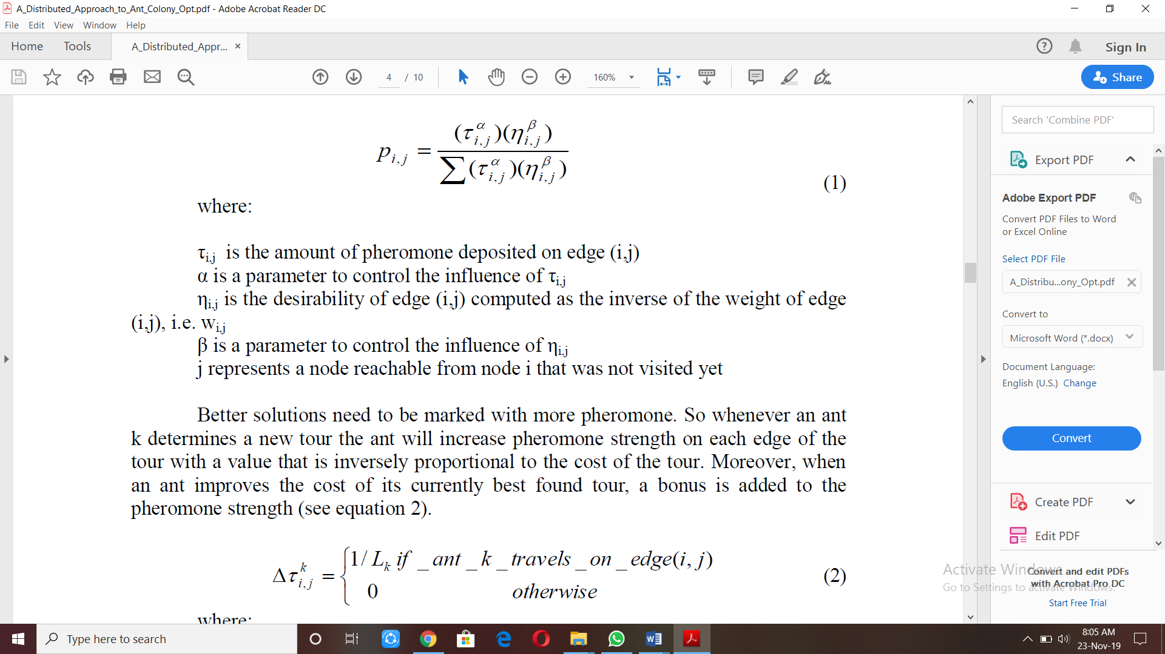
where:
τ_{i,j} is the amount of pheromone deposited on edge (i,j)
α is a parameter to control the influence of τ_{i,j}
η_{i,j} is the desirability of edge (i,j) computed as the inverse of the weight of edge (i,j), i.e. wi,j
β is a parameter to control the influence of η_{i,j}
j represents a node reachable from node i that was not visited yet

where:
L_{k} is the cost of the k-th ant's tour.
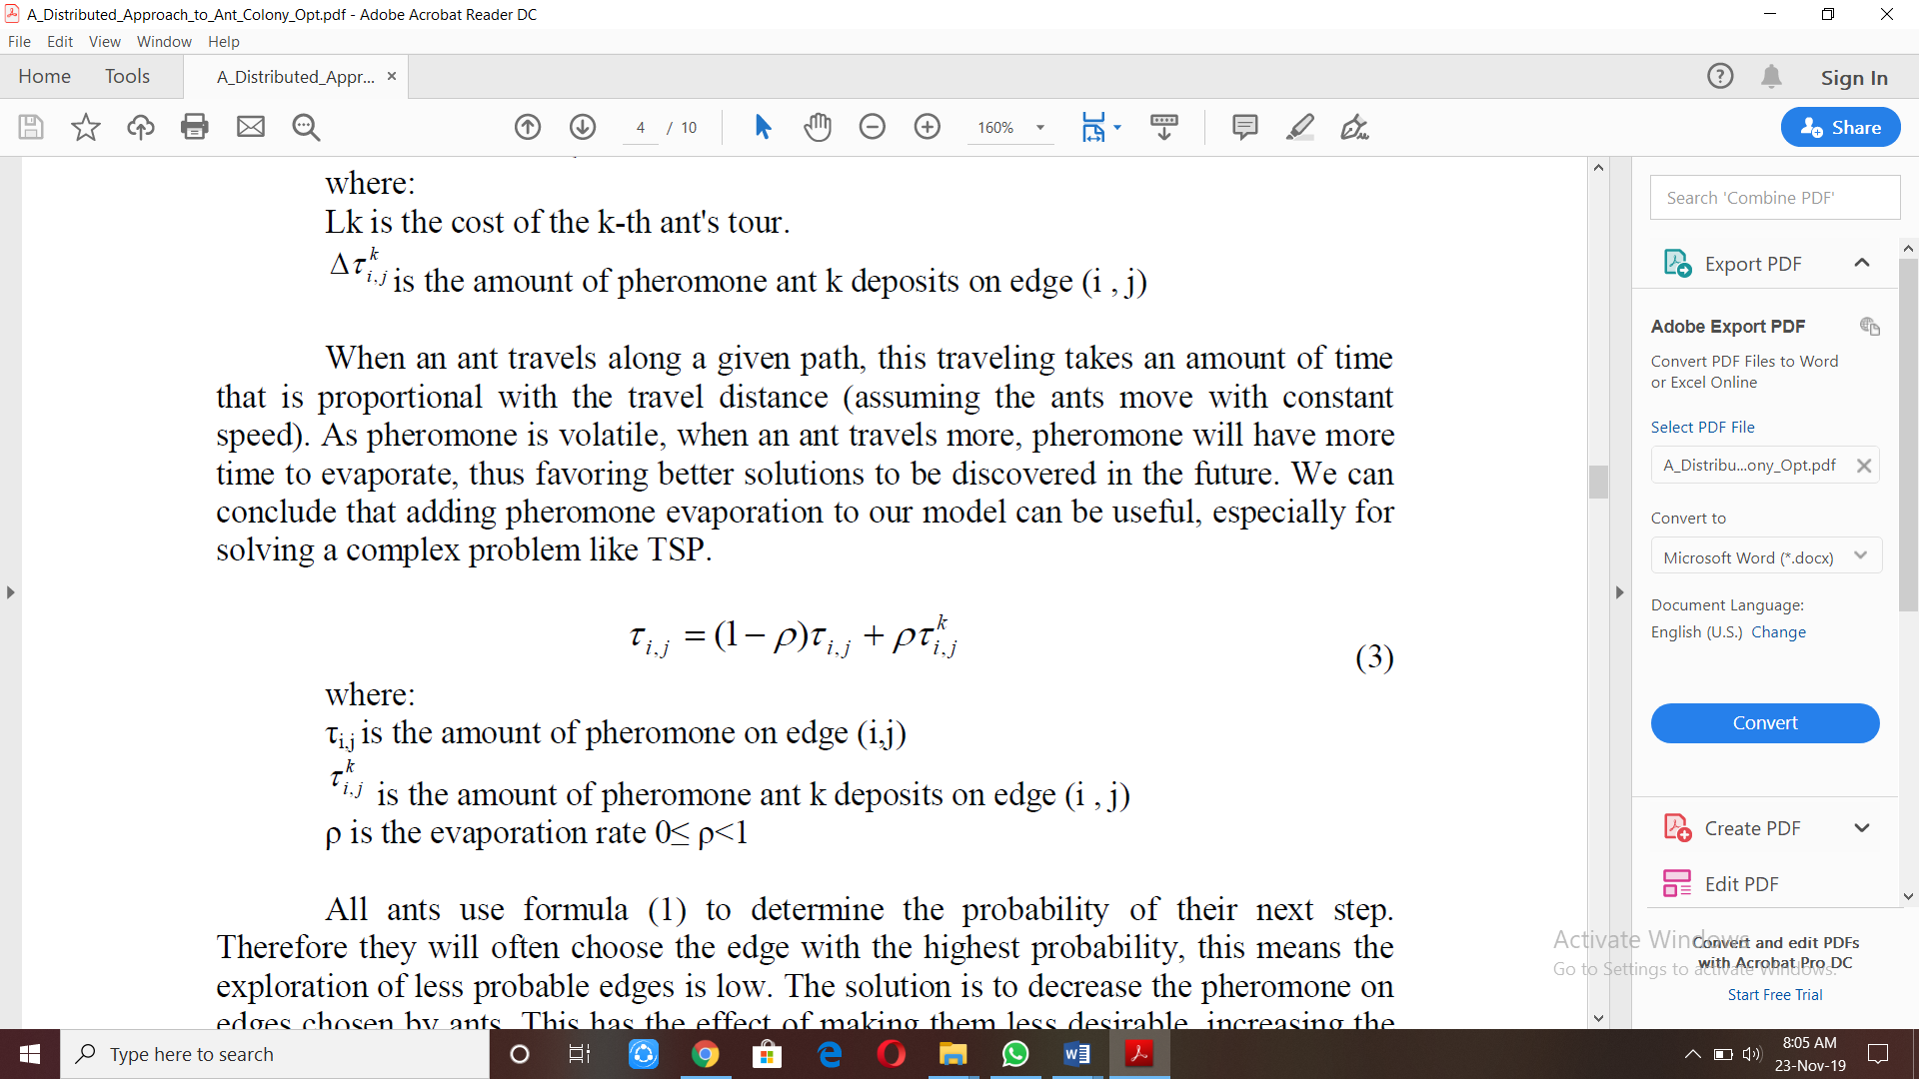 is the amount of pheromone ant k deposits on edge (i , j)
where:
τ_{i,j} is the amount of pheromone on edge (i,j)
τ_{i,j}^{k} is the amount of pheromone ant k deposits on edge (i , j)
ρ is the evaporation rate 0≤ ρ<1
Some methods like receiveAnt(), adjustAttributes(),tweak() and bestNeighbor() also used in the implementation algorithm used in the above stated procedure in [2] to find the solution of TSP problem.Nodes of the graph in the context of TSP are designed conceptualized and implemented as a network of intelligent software agents in [4],[6]The Solution of the TSP problem also can be solved in sequential manner in [7].Problem environment represented as a distributed multi-agent system and ant management has been reduced to messages that are asynchronously exchanged between agents. Utilization of experimental result gives nontrivial instances of TSP problem in [5].A new approach to solve and improve performance of TSP problem by ACO technique has been implemented by introducing i)Candidate set strategy adoption method for increasing convergence speed and ii)Dynamic updation rule based on entropy for heuristic parameter in [8].

In graph theory, the Graph Colouring Problem (GCP for short) is a special case of graph labelling; it is an assignment of labels traditionally called ‘colours’ to the elements of a graph subject to certain constraints. The GCP has three versions: vertex colouring, edge colouring, and face colouring. Here we are concerned only about vertex colouring. In vertex colouring we need to colour each vertex in such a way that no two adjacent vertices get the same colour and the chromatic number of the graph should be determined.

Graph coloring problem is a well-known combinatorial optimization problem in computer science. Solving this problem using backtracking method is very common. Since the GCP is an NP-hard [13] problem, exact algorithms can only solve problems of a relatively small size (no more than 100 vertices). Since real applications often contain very large graphs, it is difficult to obtain the minimum number of colours for the graphs while keep the constraints of the problem satisfied. Many fields of swarm intelligence can be applied to solve this problem like Ant Colony Optimization (ACO in short) [14-18], Chaotic Ant Swarm algorithm [19] etc. Here we solved this problem using “Artificial Bee Colony algorithm [20]” (ABC for short) to get the result of higher qualities.
In the ABC algorithm [20], the colony of artificial bees encompasses three groups of bees: employee bees, onlookers and scouts. A bee, waiting in the dance area for making decision to choose a food source, is called an onlooker; and a bee going to the food source which is visited at least once is named an employed bee. A bee carrying out random search is called a scout. In the ABC algorithm, the number of onlooker bees and employed bees are considered equal. For every food source, there is only one employed bee. In other words, the number of employed bees is identical to the number of food sources around the hive. Here, food sources are the same as sequences and from now on we use the word “sequence” instead of “food source”. Moreover, the number of initial sequences is denoted by NB. By starting algorithm, an initialization is done and random locations are chosen that each of them is a candidate solution. Then, all of these solutions are guided by the fitness assignment and the best sequence is chosen and is held in one variable called global-best . When initialization stage is completed the rest of process will be done inside a loop. In this loop, at first employee bees are assigned to found sequences (in initialization stage) in order to discover better solutions around the sequences. After doing this, employee bees come back to hive and offer the quality of what they have found and onlooker bees choose one of them according to the quality of the advertised sequences. Then, onlookers go and try to find other sequences around previous found sequences. It is clear each employee finds a sequence that has better quality and it can gather further onlookers. For each sequence, bees search around it until they are dissatisfied from that sequence. After dissatisfaction, a scout bee goes and finds another random sequence in search space while employee bee leaves previous sequence and migrates to a new one. This process is done in loop frequently for a fixed number of times. Here, 2500 iterations.

The N-Queen problem is one of the prominent problems for performance assessment in the domain of Computational Intelligence. The problem can examine the diverse aspects of solving techniques, counting the potential of obtaining feasible solution and time & space complexity. The well-defined set of constraint sketches out the overall problem. The Queen has various attacking options over the chessboard. In point of fact, it can walk off across the column, row and two diagonal. The feasible solution of N-Queens demands the non-attacking placements
over the chessboard. This research inspects the effectiveness of Particle Swarm Optimization (PSO) in order to solve the problem. In PSO, the particle contains a structured set of queen placements. current position of particle is well directed by the xBest and gBest parameters, each new generation obtains more converged set of particles. The particle but improved outcome promotes and furnishes to succeeding generation while the substandard may be discarded. The investigational results make known the dynamic features of PSO and eventually validate the effectiveness of research direction [11].
Particle Swarm Optimization was developed in 1995 by the authors Kennedy and Eberhart inspired by the behavior of social organisms in groups, such as bird and fish schooling or ant colonies[12]. This algorithm emulates the interaction between members to share information. Particle swarm optimization has been applied to numerous areas in optimization and in combination with other existing algorithms. This method performs the search of the optimal solution through agents, referred to as particles, whose trajectories are adjusted by a stochastic and a deterministic component. Each particle is influenced by its ‘best’ achieved position and the group ‘best’ position, but tends to move randomly. A particle ‘i’ is defined by its position vector, x_{i}, and its velocity vector, v_{i} [9]. Every iteration, each particle changes its position according to the new velocity as in Refs. [9]:
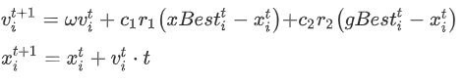
where xBest and gBest denote the best particle position and best group position and the parameters ω, c₁, c₂, r₁ and r₂ are respectively inertia weight, two positive constants and two random parameters within [0, 1]. In the baseline particle swarm optimization algorithm ω is selected as unit, but an improvement of the algorithm is found in its inertial implementation using ω ≈ [0.5 0.9]. Usually maximum and minimum velocity values are also defined and initially the particles are distributed randomly to encourage the search in all possible locations.

3. PROPOSED WORK

Earlier we have seen solution and implementation of:
- Travelling Salesman Problem (TSP) by Dynamic Programming Approach.
- Graph Coloring Problem by Backtracking Approach and
- N-Queen Problem by Backtracking Approach.
Here we observe implementation of Nature Inspired Approaches to solve problems like:
- Travelling Salesman Problem (TSP) by Ant Colony Optimization (ACO) method.
- Graph Coloring Problem (GCP) by Artificial Bee Colony (ABC) algorithm method and
- N-Queen Problem by Particle Swarm Optimization (PSO) method.
Our work is to perform a comparison based study of the solution of Travelling Salesman Problem(TSP),Graph Coloring Problem(GSP) and N-Queen Problem by using general algorithmic approaches(Dynamic Programming, Backtracking) and by using nature inspired optimization techniques(Ant Colony Optimization, Artificial Bee Colony, Particle Swarm Optimization).Analysis of performance will give the idea about the best approach to be taken for the solution of the above mentioned problems.

4. CONCLUSION

Nature is a rich inspirational source and there is still much to learn from. We can take advantage of the social collective behaviour of swarms to solve our real-life problems, by observing how these swarms have survived and solved their own challenges in nature. Several simple agents interacting locally among themselves can eventually emerge a sophisticated global behaviour. Different Swarm Intelligence based computational models are fast-growing, as they are generally computationally inexpensive, robust and simple. Swarm Intelligence based optimization techniques are far-reaching in many domains, and have a wide-range of successful applications on different areas.
In this paper, the main concepts and principles of Swarm Intelligence are presented,
with a particular focus on three of the most successful and popular Swarm Intelligence inspired optimization techniques: Ant Colony Optimization, Bee Colony Optimization and Particle Swarm Optimization. It was both challenging and interesting to study and research on this topic. On one hand, it was completely new to us, as well as relatively recent and interdisciplinary. On the other hand, it was very interesting to learn how astoundingly intelligent the social collective behaviour of swarms in nature, and see how amazing is it to uncover some of nature’s secrets, as well as realize how knowledge from different disciplines (such as, animal behaviour, physics, social psychology and social sciences) can actually work in harmony together, and practically be used in computer science and beyond.

5. REFERENCES

- J.L. Bentley. Fast Algorithms for Geometric Traveling Salesman Prob- lems. ORSA Journal on Computing, 4(4):387–411, 1992.
- H. Bersini, M. Dorigo, S. Langerman, G. Seront, and L. Gambardella. Re- sults of the First International Contest on Evolutionary Optimisation. In Proceedings of the IEEE International Conference on Evolutionary Com- putation (ICEC’96), pages 611–615. IEEE Press, 1996.
- K.D. Boese. Models for Iterative Global Optimization. PhD thesis, Uni- versity of California, Computer Science Department, Los Angeles, 1996.
- K.D. Boese, A.B. Kahng, and S. Muddu. A New Adaptive Multi-Start Technique for Combinatorial Global Optimization. Operations Research Letters, 16:101–113, 1994.
- E. Bonabeau, M. Dorigo, and G. Theraulaz. From Natural to Artificial Swarm Intelligence. Oxford University Press, 1999.
- B. Bullnheimer, R.F. Hartl, and C. Strauss. An Improved Ant System Al- gorithm for the Vehicle Routing Problem. Annals of Operations Research. To appear.
- B. Bullnheimer, R.F. Hartl, and C. Strauss. A New Rank Based Version of the Ant System — A Computational Study. Central European Journal for Operations Research and Economics. To appear.

- B. Bullnheimer, R.F. Hartl, and C. Strauss. Applying the Ant System to the Vehicle Routing Problem. In S. Voss, S. Martello, I.H. Osman, and C. Roucairol, editors, Meta-Heuristics: Advances and Trends in Local Search Paradigms for Optimization, pages 285–296. Kluwer, Boston, 1999.

- 1.van den Bergh, F. and Engelbrecht, A. P. Training product unit networks using cooperative particle swarm optimisers. Proceedings of INNS-IEEE International Joint Conference on Neural Networks 2001, Washington DC, USA. 2001.
- 2.van den Bergh, F. and Engelbrecht, A. P. Training product unit networks using cooperative particle swarm optimisers. Proceedings of INNS-IEEE International Joint Conference on Neural Networks 2001, Washington DC, USA. 2001.
- Eberhart, R. C. and Kennedy, J. A new optimizer using particle swarm theory. Proceedings of the Sixth International Symposium on Micro Machine and Human Science, Nagoya, Japan. pp. 39-43, 1995,
- 4.Kennedy, J. and Eberhart, R. C. Particle swarm optimization. Proceedings of IEEE International Conference on Neural Networks, Piscataway, NJ. pp. 1942-1948, 1995.

- M. R. Garey and D. S. Johnson, “Computers and Intractability: a guide to the theory of NP-Completeness.”, W. H. Freeman and Company, New York, 1979.
- D. Costa and A. Hertz, “Ants can colour graphs.”, J Oper Res Soc, (48):295–305, 1997.
- T. N. Bui, T. H. Nguyen, C. M. Patel and K-A. T. KPhan, “An ant-based algorithm for coloring graphs.” Discrete Appl Math, 156 (2):190-200, 2008. doi:10.1016/j.dam.2006.07.012
- K. A. Dowsland and J. M. Thompson, “An improved ant colony optimisation heuristic for graph colouring.”, Discrete Appl Math, 156 (3):313-324, 2008. doi:10.1016/j.dam.2007.03.025
- E. Salari and K. Eshghi, “An ACO algorithm for graph coloring problem.”, Computational Intelligence Methods and Applications, vol., no., pp.5 pp., 0-0 0, 2005. doi: 10.1109/CIMA.2005.1662331
- A. SangHyuck, L. SeungGwan and C. TaeChoong, “Modified ant colony system for coloring graphs.”, Information, Communications and Signal Processing, and the Fourth Pacific Rim Conference on Multimedia. Proceedings of the 2003 Joint Conference of the Fourth International Conference on, 15-18. pp 1849-1853 vol.1843, 2003.
- F. Ge, Z. Wei, Y. Tian and Z. Huang, “Chaotic ant swarm for graph coloring.”, Intelligent Computing and Intelligent Systems (ICIS), IEEE International Conference on, vol.1, no., pp.512-516, 29-31, 2010 doi: 10.1109/ICICISYS.2010.5658530
- D. Karaboga and B. Basturk, “A powerful and efficient algorithm for numerical function optimization: artificial bee colony (ABC) algorithm.”, J Glob Optim (39):459–471, 2007. doi:10.1007/s10898- 007-9149-x

